

**Hammering out solutions since 2013**

**Strong Arm Consulting**

|  |
| --- |
| AL&AL Consulting Project |
| Evaluation of Bid History and Engineering Firms |
|  |
| Strong Arm Consulting was contracted with evaluating AL&AL Construction Inc.’s Bid History to develop a model whether or not AL&AL Construction should bid on future projects. Furthermore, we compared two engineering firms’ performance on how accurate their cost estimation were in the past in order develop recommendation engine for future projects. |
|  |

­

AL&AL Consulting Project

Evaluation of Bid History and Engineering Firms

# Key Findings

• • •

If there are less than **nine competitors** AL&AL has a much higher chance of winning the bid

Stay out of the **Mid-West**

Avoid small project

Invest in long-term project

No difference in profit margins across sectors and regions

# Executive Summary

Consulting found based on the AL&AL Construction Inc.’s (AL&AL) bid history that the most determining factor of whether a bid is won is the number of competitors. Other important factors included the sector and region of the projects, which generally describe the basic characteristics of each project. We created a software tool based on the model we developed to allow AL&AL’s management to make confident bidding decisions with basic information of the project.

All graphics are also available in an interactive format in our application, which is part of our model delivery for dynamic understanding of AL&AL’s historic bidding data.

# Analytical Methods

## Competition Analysis

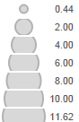 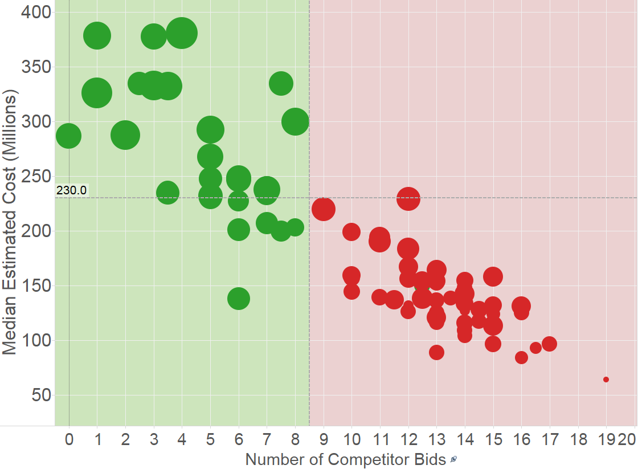

1: Years to Complete

The graphic above summarizes some of our key findings. It displays all available project bid history available to us grouped by sector and region. For example, one dot would represent Transportation in the Northeast while another might represent Military projects in the West. It is clear to see from the illustration that there is a significant difference in the outcome of our bidding based on how many other proposals we compete against. AL&AL is doing a much better job when bidding on high value projects that naturally can only be handled by fewer firms. These projects, which we are more successful in securing, normally also demand a longer commitment of our firm as shown by the size of the dots.

We also evaluated the key competitors’ influence on the outcome of the bid. However, none of them impacted the outcome enough to include them into our final model.

## Geographic and Sector Analysis

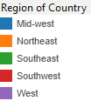 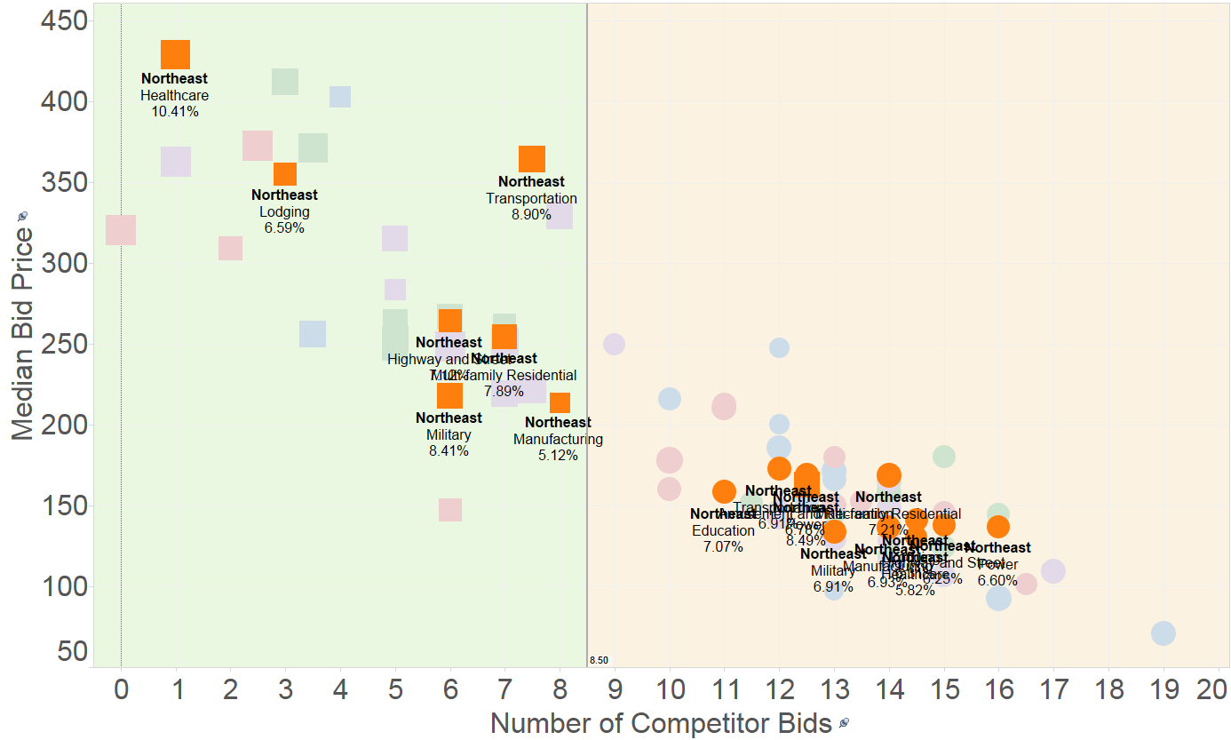

The Northeast region represents the typical case for most regions. AL&AL is very successful in the sectors that offered the opportunity to bid on large scale projects, while not securing the smaller budgeted projects with high competition. This pattern holds across all regions, but the Midwest. As illustrated below the Midwest was a highly competitive market for small scale projects.

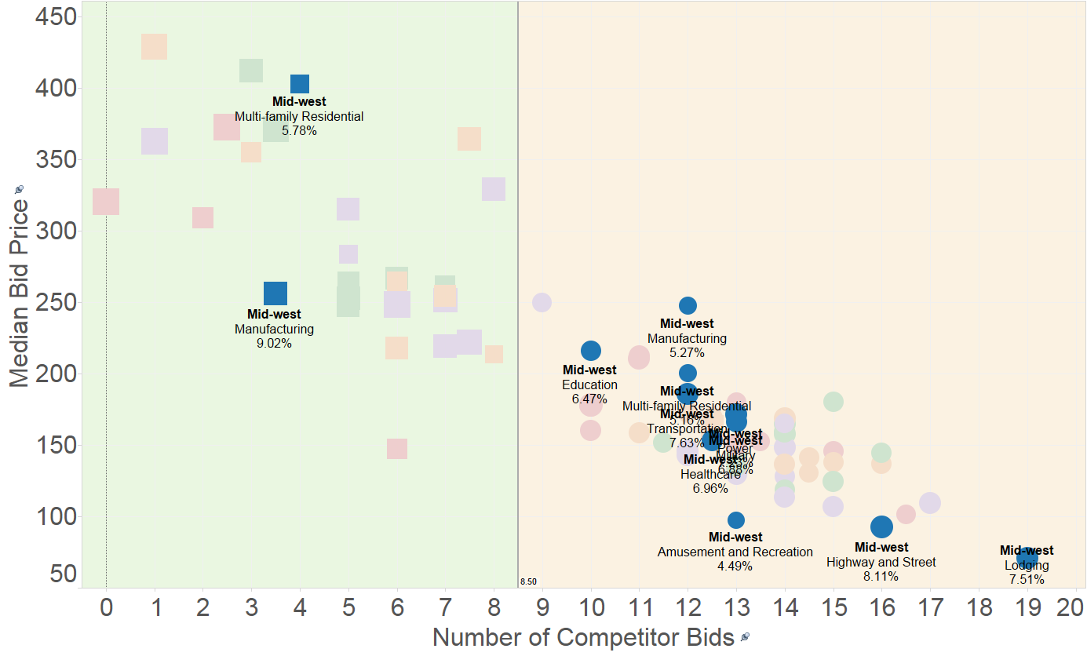

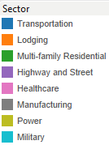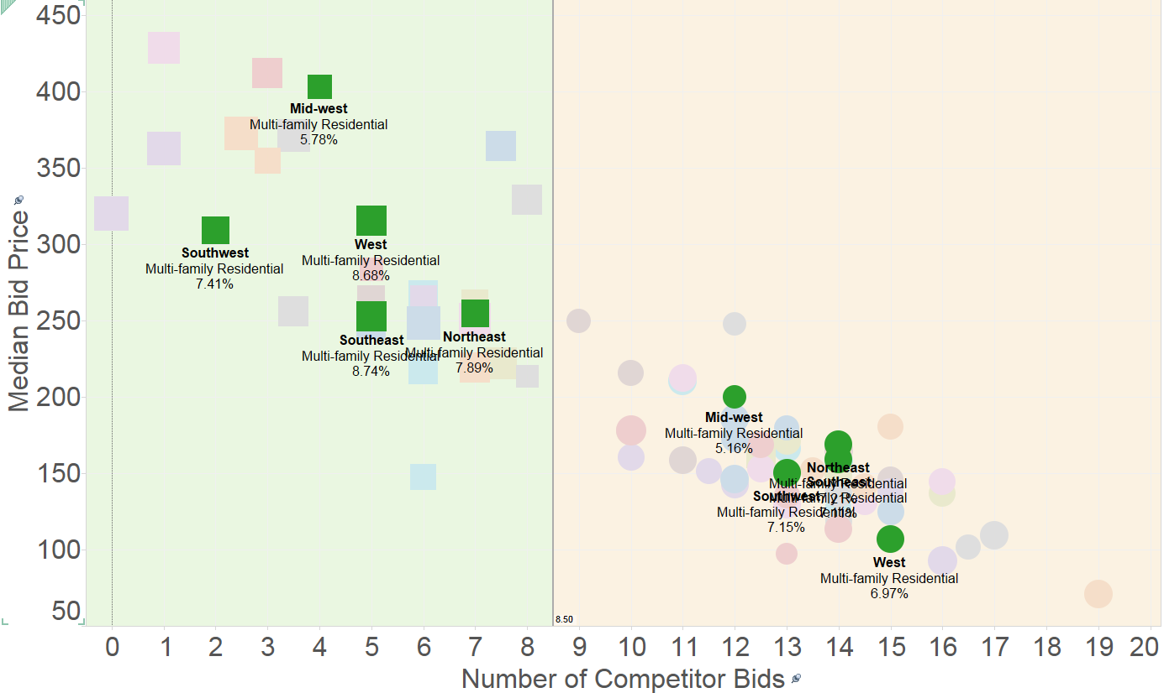

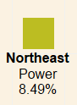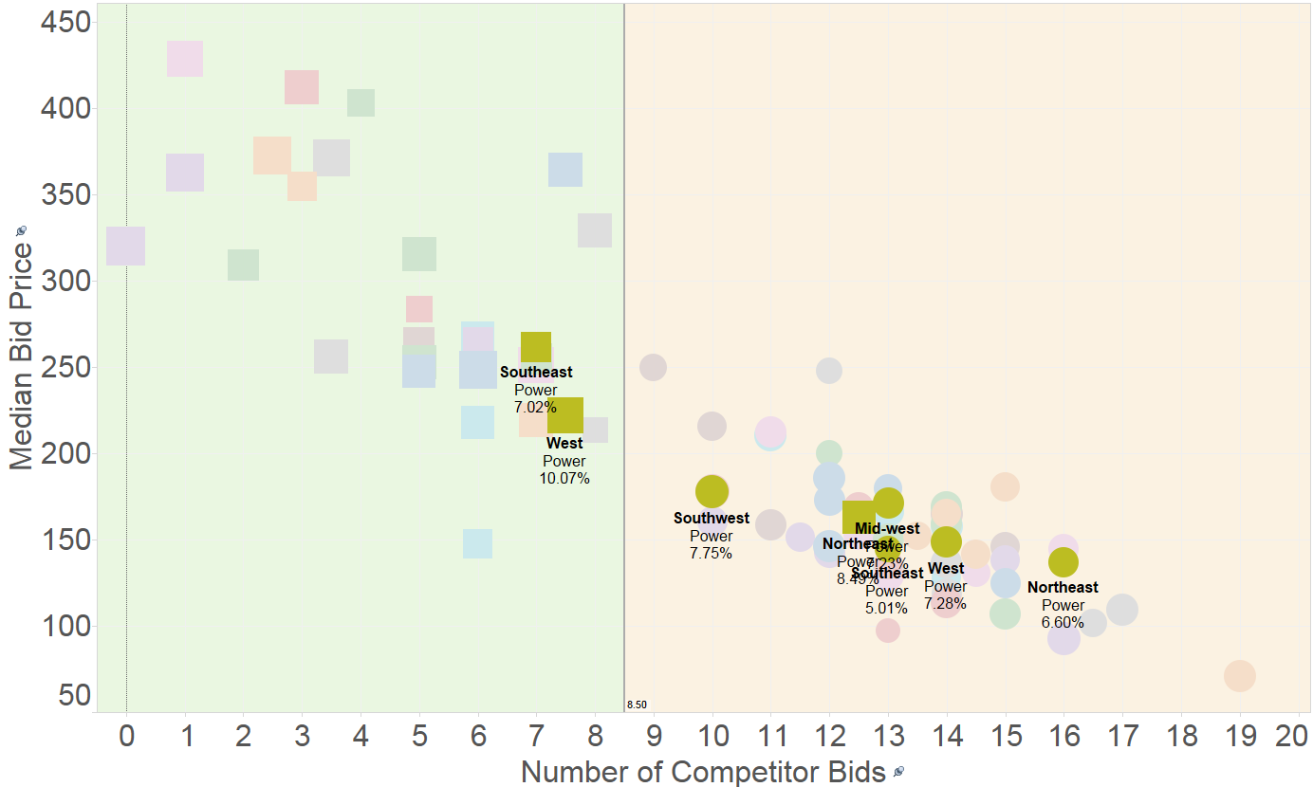If broken down by sector the projects reveal to prevalent patterns mirroring the two patterns we saw earlier on a regional basis. Above we have the typical split pattern where we have our successful bids on larger, less competitive projects split evenly with smaller, more competitive projects. We found this to be true for all sectors, but Amusement & Recreation, Education, Healthcare and Power. Our general competition rule holds for all observations with the only exception being some Power related projects in the Northeast.



### Profit Margins

Another added benefit of bidding in less competitive markets is that we have more room to boost our margins. We could not find any difference between sectors and regions, however the large scale projects like the ones AL&AL successfully operates in Strong Arm Consulting found that the margins a slightly higher than in the high competitive, small project. We also found certain sectors to be more profitable than others as shown below. However, AL&AL still outperforms the market in all its successful bids.

